Topic Cover
History HT5 -Famous Kings and Queens of Britain.

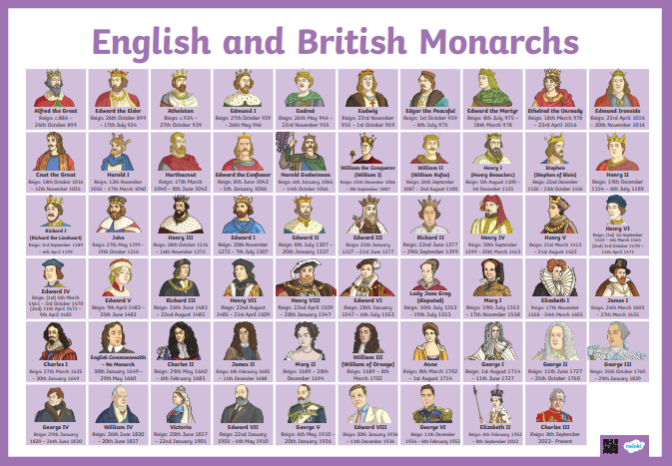

Key Questions:

- How can we find out about the past?
- Where did Kings and Queens of Britain live, through time?
- Why did monarchs build castles?
- Who was Queen Elizabeth II and where did she live?
- Which monarch is presently on the throne?
In exploring these areas, the children will develop an awareness of the past, using common words and phrases relating to the passing of time.

