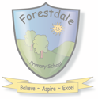
Year 4!
In half term five, we will be learning about…
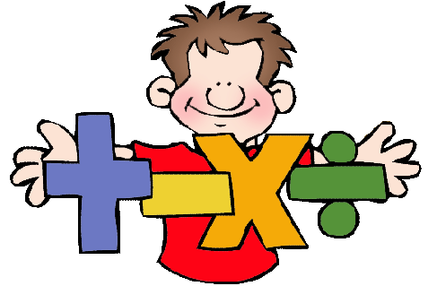

Maths
- Decimals
- Time
- Statistics
- Money
It would be really helpful for your child to continue practising their number bonds and multiplication facts at home!
Writing

- Narrative Writing
- Poetry
We will also be recapping punctuation and grammar from previous years before learning more.


Homework

Spelling - we will hand out spelling homework each Friday for a test the following Friday – please help your children practise their spellings at home. There will also be games set each Friday online for children to practise their spellings through Spelling Shed.
Maths – each week your child will be set work on TTRS to improve their knowledge of the multiplication tables this will help embed their learning.
Reading – children will be sent home with home reader books. Please ensure that you read them with your child and log their reading on BoomReader.
Curriculum – homework for other areas of the curriculum will be sent home through a variety of tasks for you to complete with your child.

Reading

In reading this half term we will be reading The Last Bear and related non-fiction texts.
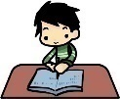

Science

In Science we will be learning about sound.




PE
Year 4 have PE on Mondays and Tuesdays - please come to school in PE kit. This half-term we will be looking at striking and fielding.

Other Curricular Areas

- In French, we will be continuing to learn about portraits- describing in French.
- In Computing, we will be finishing audio editing and learning about managing online information.
- In Jigsaw, we will be exploring ‘Healthy Me’.
- In music we will be learning how to play the Ukelele.
- In Art we will be exploring sculpting and 3-D mega materials.
- In Design and Technology, we will be making pavilions.
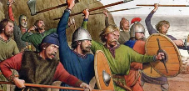
Humanities

In History this half term, we will be continuing to learn about the Anglo-Saxons. We will be learning about: how the Anglo-Saxons kept control of their kingdoms, their weaponry and about Anglo-Saxon life.

We will then be moving onto to Geography where we will be comparing England and Mexico, as well as developing map our skills.

