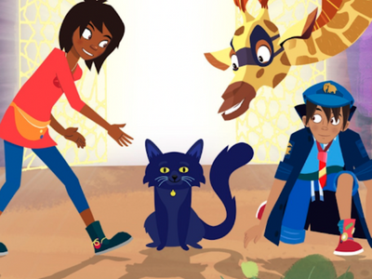
Year 1 English Lesson (1 Hour)
Theme: Meeting a Mysterious Cat
Learning Outcome
By the end of the lesson, children will be able to:
- Use picture clues to talk about characters and settings
- Create simple sentences using capital letters and full stops
- Describe a character using adjectives
- Sequence ideas to tell a short story

Starter (10 minutes)
Activity: Picture Talk
Show the image to your child and ask these prompts:
- Who can you see in the picture?
- What animals or people are there?
- What do you notice about the cat?
- Where do you think they are?
- How do the characters feel?
Encourage full sentences, for example:
“I can see a cat with bright eyes.”

Main Activity (30 minutes)
Task: Write 3–5 sentences about the scene
Guide your child to create a short description or beginning of a story.
Step-by-step support:
- Character clues:
  - A black cat sitting in front
  - A boy in a blue uniform kneeling
  - A giraffe peeking in curiously
  - A girl reaching out her hand
- Setting clues:
  - Indoors
  - Bright patterns behind them
- Sentence starters to choose from:
  - The cat looks…
  - The boy is…
  - The giraffe is…
  - They are in…
- Adjectives to choose from:
  - friendly, tall, shiny, brave, curious, soft, magical
Encourage the child to use:
- A capital letter at the start
- Finger spaces
- A full stop at the end
Example (for adult reference only):
The cat sits on the floor. The girl reaches out her hand. The giraffe looks curious. They might be trying to help the cat.

Extension (optional, 10 minutes)
Create a Character Description
Ask your child to choose one character and describe them using 3 adjectives.
E.g.:
The cat is shiny, small and magical.

Task 2 - Write a Short Story (Beginning, Middle, End)
Tell your child they are going to write a short story inspired by the picture.
Use this structure:

Beginning
Introduce the characters.
Sentence starters:
- One day, a magical cat appeared…
- A boy, a girl and a giraffe found a cat…

Middle
Describe what the characters did.
Sentence starters:
- The cat wanted to show them something…
- The friends followed the cat because…
- Suddenly…

End
Explain how the story finishes.
Sentence starters:
- In the end, they discovered…
- They all felt happy because…
- The cat said goodbye and…

Success Criteria for Year 1
✔ Capital letters
✔ Finger spaces
✔ Full stops
✔ Try adjectives
✔ Try writing more than one sentence
Encourage the child to write 3–6 sentences.

4. Plenary (10 minutes)
Ask your child to read their story aloud.
Then ask:
- “What did you enjoy writing today?”
- “How did you make your story interesting?”
- “What might happen next?”
Praise their effort, neat work, and imagination.

